**AN ONLINE ROAD TRANSPORT BOOKING SYSTEM**

Mensah Yaw#1, Adekola Olubukola #2

Department of Software Engineering, Babcock University, Ilisan-Remo, Ogun, Nigeria.

1mensahy@babcock.edu.ng

2adekolao@babcock.edu.ng

**Road transportation bookings have traditionally been done over the counter in transportation terminals, but with the exponential growth of e-commerce, this has changed. This research focuses on automating the Road Transport Booking System to allows travelers (passengers) and employees to buy and sell tickets online. This research also discusses issues that consumers and administrators face, such as long wait times to book a trip, unsafe environments, and more. The project investigates several implementation problems and makes suggestions about how to successfully incorporate an Online Road Transport Booking System. This web portal would aid future development of a fully integrated system that connects transportation company employees to consumers, employees to employees, employees to other types of transportation providers, employees to companies, and employees to government agencies. The programming tools used in the development of this research are PHP, CSS, HTML, JavaScript, MYSQL database, and XAMPP server.**

**Keyword -** Road, Transport, Online, Booking, Database, Server

**I. INTRODUCTION**

Transport implies the movement of individuals or merchandise from one point to another through various mediums such as cars, trains, airplanes and even animals such as donkeys, camels etc. It can be characterized into three different types based on the surface they travel on. The diverse modes include water (shipping), air and land (road, pipeline and rail). Transportation was available before the inception of the modern means of transportation [1]. Such traditional means include the human powered transport which utilizes the human muscle-power for walking and running. Although some of these methods are still in use today for short distance travel, the human-power has greatly been improved with modern technologies. Human-power transport remains popular for reasons of relaxation and physical exercise. In spite of the fact that people are able to move around without any infrastructure, the transport can be improved through the utilization of roads, particularly when utilizing the human-power with vehicles, such as bikes and cars. Transport booking amid the offline era posed different troubles to the clients as well as the transport administrators According to [2], Offline ticket booking reduced the scope of customers to choose different options based on their travel criterion [3]. The road transport booking system is an electronic system that allows customers to have access to travel tickets by buying the transport tickets, check available seats, pick departure date etc. [4]

Prior to the advancement of Road Transport Booking System, road transport never utilized any framework to keep records of booking, rather records of booking and storage of transport data where hand written and this has led to time consuming when storing data, insecurity of data, delay in accessing data and reiteration of uniform data records due to the staffs inability to recover the list of documents and exchange made in past. To alleviate the above lacuna and thus achieving better data storage and booking there is a need for an online Road Transport Booking System. This research aims at developing a web-based transport booking system that will replace the traditional means of operation and also satisfy the facilitation of all transactions online with effectiveness.

**II ROAD NETWORK PATTERN AND ANALYSIS**

Road network comprises of huge number of joined roads showing numerous patterns extending from star-like to grid-like with sporadic patterns getting to be recognized [5]. It comprises of sizeable number of roads that are intertwined with each other to show a pattern. The recurrence of such patterns warrants development of prototypical views of topographical processes [6].

According to [7], the route network is a collection of nodes representing topological areas and shows topological and geometric modifications, whereas topology itself alludes to the arrangement and association of nodes and links of a network. The route network is made up of secondary and primary roads called minor and arterial roads accordingly. Road network constitutes a significant component in urban growth as roads give access required by distinctive land uses and the right operation of such urban zones relies on effective transport network, which is the main reason for their very existence [8]. Analyzing the road networks has to do with recognizing the pattern and qualities of the roads. [9]considered the view of events as objects and contended that patterns themselves are objects confined in space, arranged in order, and distinguishable by a set of unique qualities. The qualities can be stressed through the method of abstraction and representation where pattern is seen as complexes of ancient objects and the relationship between them. This gives the structure, degree, arrangement, thickness, topology and setup as their inherent properties. Topology, as stated by [10], is a course of action and connection of nodes and links of measuring the solid structure whereas configuration alludes to a collection of entities that contain the model of road networks.

**III THE PROPOSED SYSTEM MODEL**

After conducting a review of the current models and identifying its flaws, we considered the possibility of implementing an advanced, reliable, and competitive system to incorporate a web-based road transportation booking system. The system's architecture and implementation are all very straightforward. The framework only uses a limited amount of system resources and can be used in virtually any configuration. It has the following characteristics: (a) Ensures the accuracy of data. (b) The database efficiently maintains all records. (c) Anyone with access to the internet anywhere in the world can use this service. (d) Bookings cannot be cancelled for different processing; a minimum amount of time is needed. (e) Better service. (f) This will encourage the organization to effectively manage and coordinate its schedules based on traffic demand. (g) Optimization of available manpower.

**frontend**

**Web Application**

**User**

**Panel**

**Admin**

**Panel**

**Backend**

**Database**

Figure 1. The Online Road Transport Booking Model

The proposed model is a two-tier architecture which comprise the frontend and backend as shown in Figure 1.

*Backend*

The backend consists of an online relational database which is used to store road transportation booking processes for further use and also ensures accuracy of data whereby encouraging road transport organization to effectively manage and coordinate its schedules based on traffic demand.

*Frontend*

The frontend consists of the web application which display the admin and customers view such as home page module, login module, staff management module, bus information module, purchasing, news module, registration module, booking module, payment module, and ticket module,

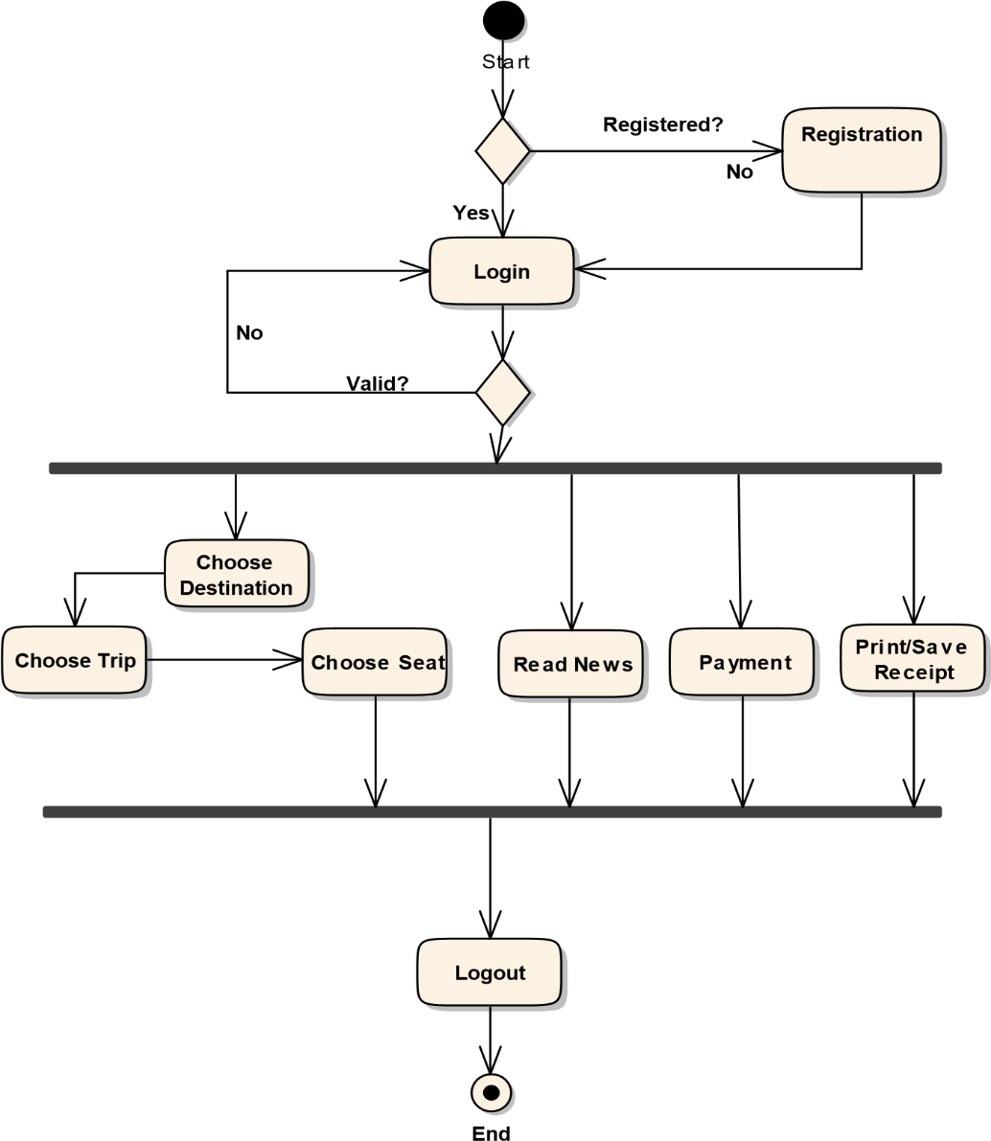

Figure 2. Activity Diagram for the Proposed Model

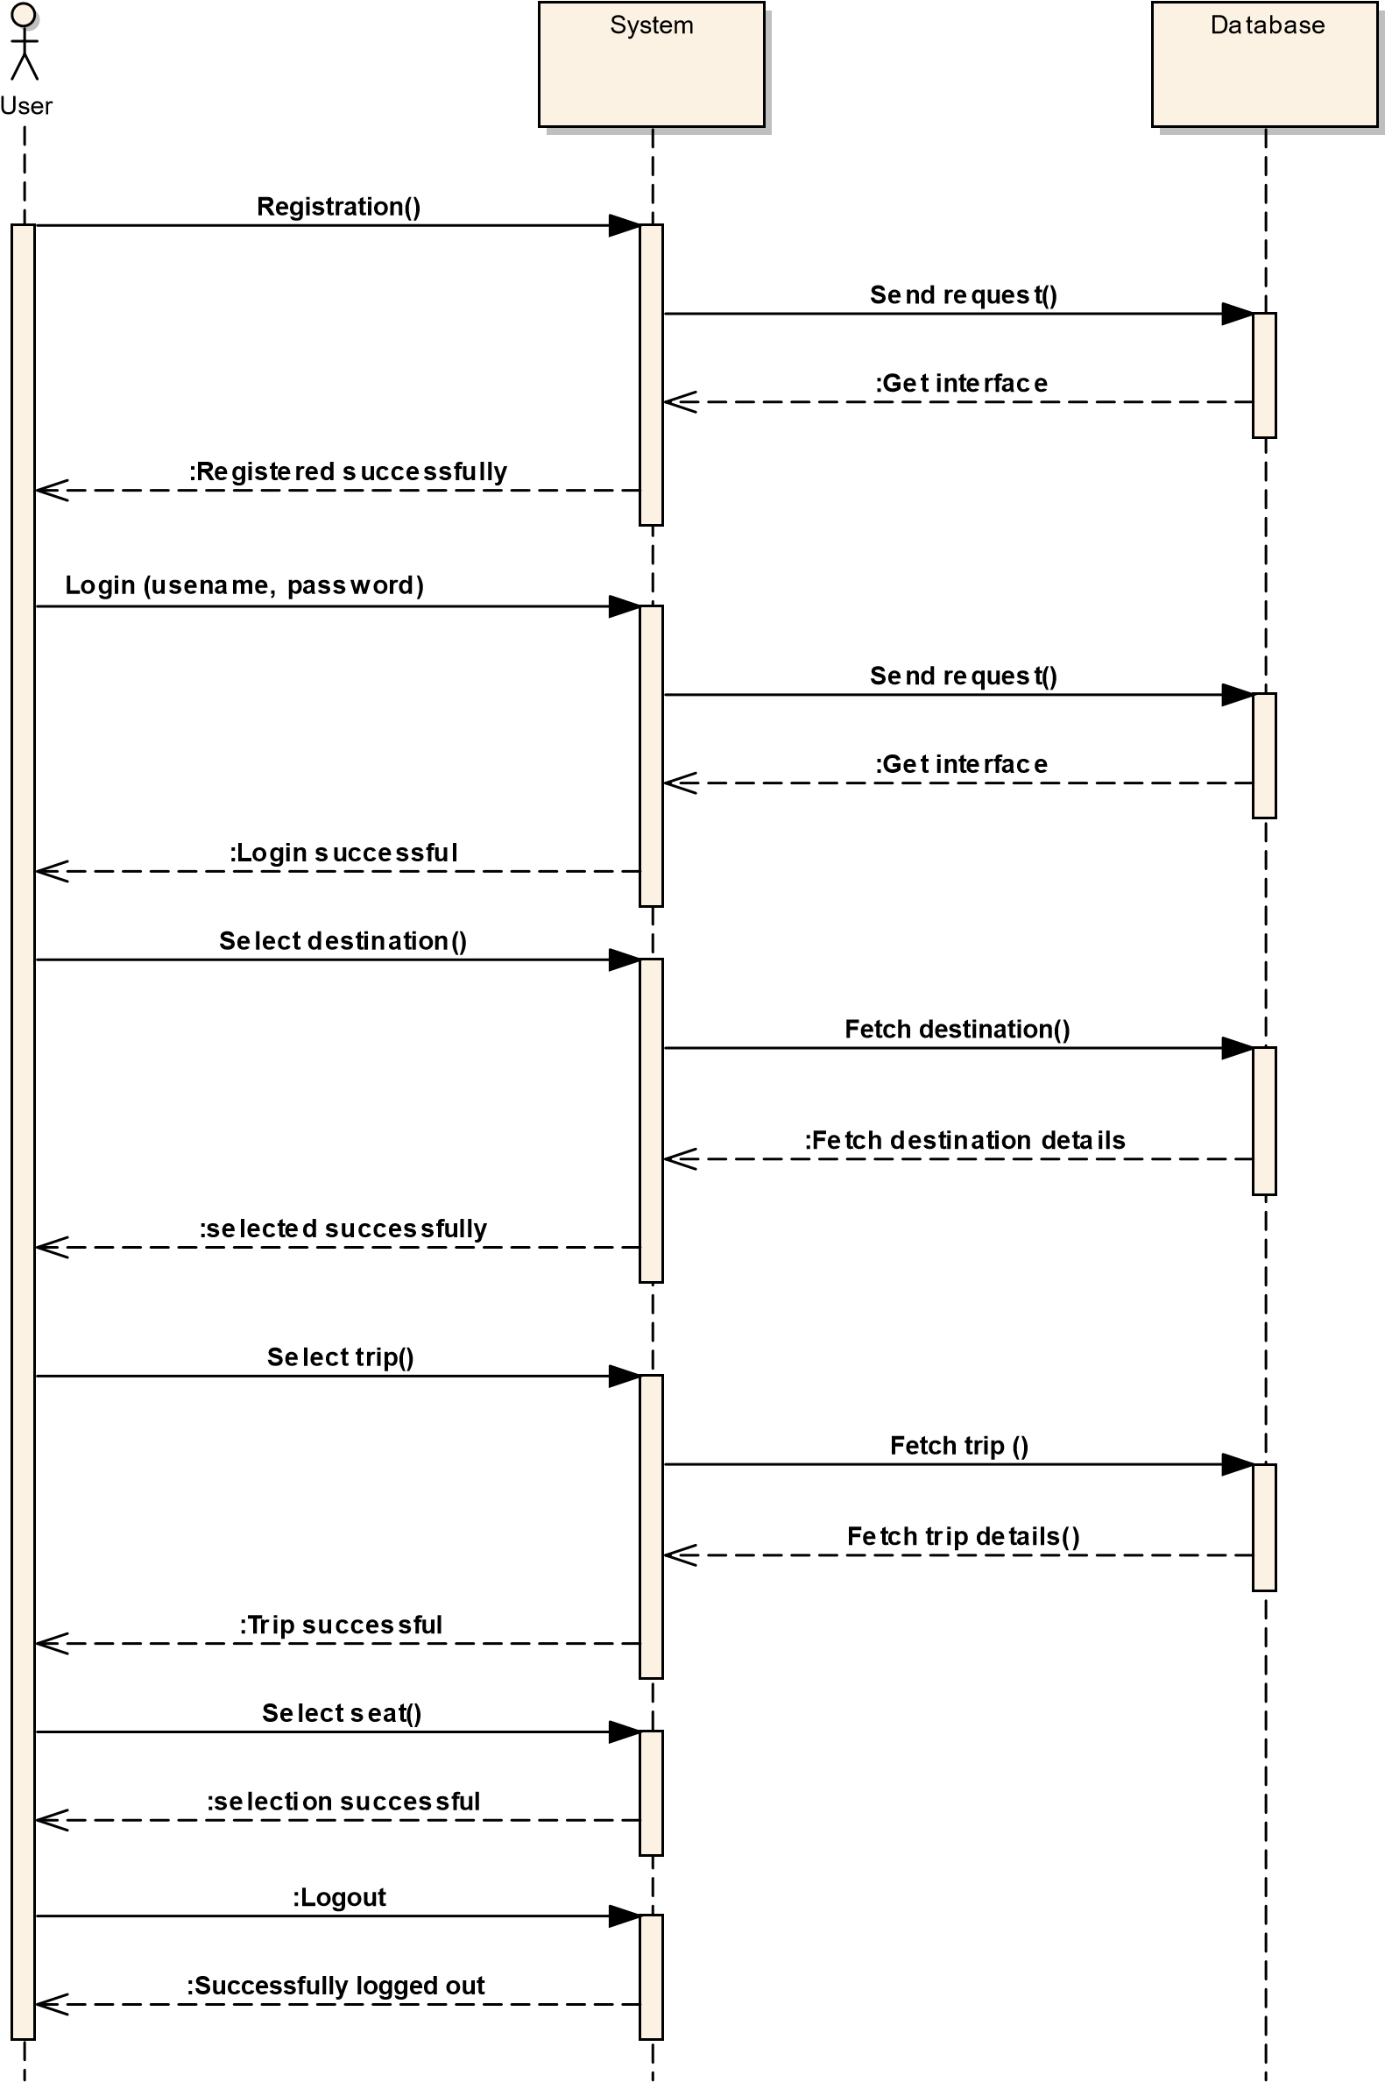The sequence diagram, also known as an event diagram, depicts the flow of messages through a system. It aids in the visualization of a variety of complex scenarios. It depicts the interaction between any two lifelines as a time-ordered series of activities, as if these lifelines occurred at the

Figure 3. Sequence Diagram for the Proposed Model

**IV SYSTEM IMPLEMENTATION**

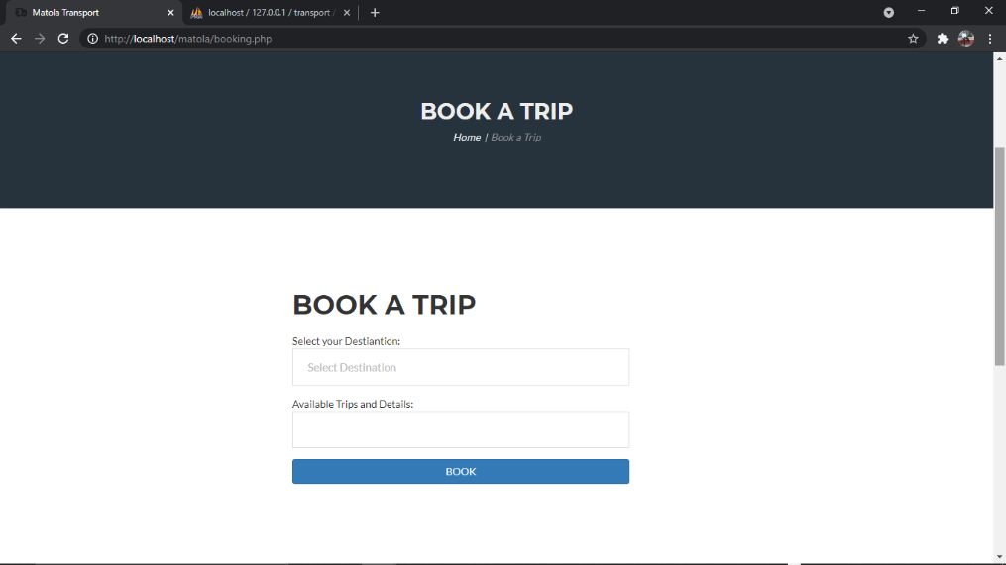

Figure 4. Booking page

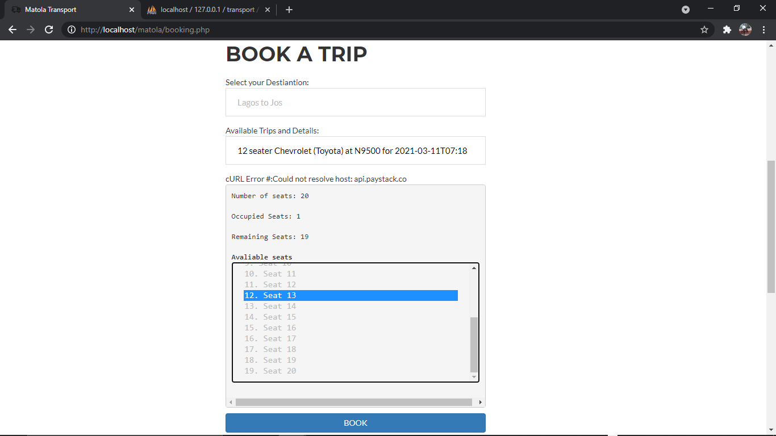

Figure 5. Booking page

Figures 4 and 5 shows a page where the consumer can book a trip. Customers can also select their preferred seat number. Only available seat numbers are displayed on the seat selection menu. Only an authenticated person has access to this page.

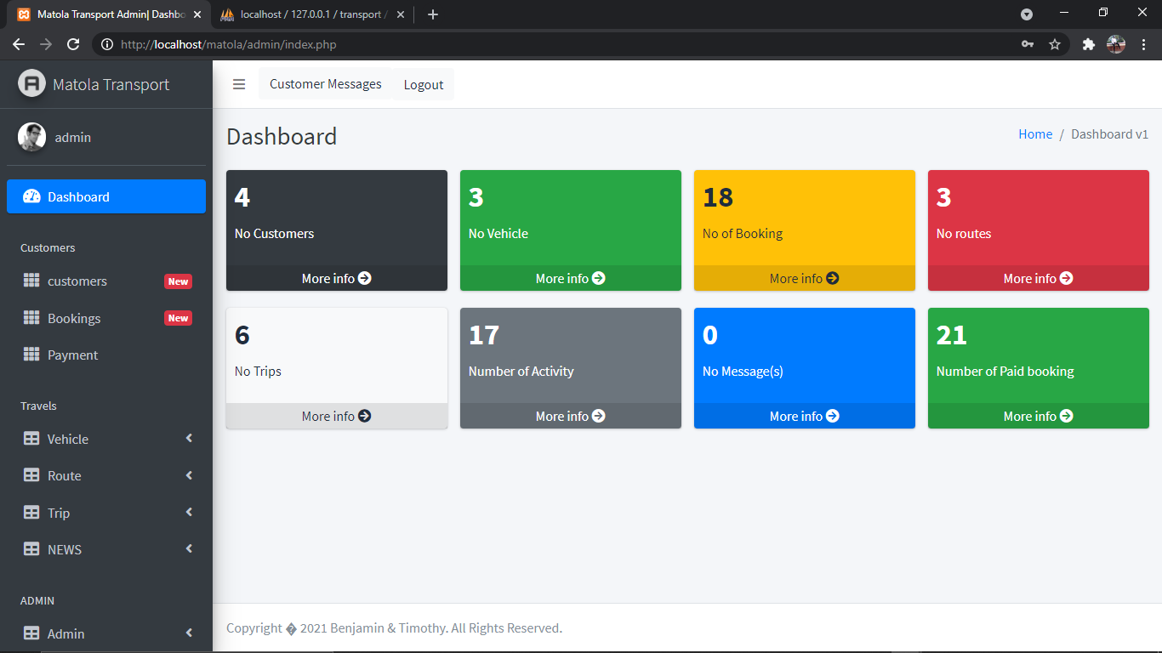

Figure 6. Admin home page

Figure 6. displays the admin home page. The admin can select which option they want to perform first.

**CONCLUSION**

The online road transportation ticketing system web portal is a system with its strengths and limitations. An in-depth study and the implementation of a web portal on the online road transport booking system was conducted. An investigation of some electronic bus ticketing sites had also been conducted. Overall, the online road transportation booking system has been successfully built and has met and fulfilled the objectives and requirements set out on the research. The use of a web approach brings many advantages, in particular, the possibility of accessing information everywhere and at any time of the day.

# REFERENCES

|  |  |
| --- | --- |
| [1] | C. C. Jean-Paul and B. S. Rodrigue, The Geography of Transport Systems-Claude Comtois, B. Slack, Ed., Google Books, 2009. |
| [2] | S. Gayathry, "Online Bus Ticketing System," *Tactful Management Research Journal Through Case Studies,* vol. 7, no. 5, pp. 10-20, 2013. |
| [3] | K. Melisa and S. Narjan, "Online Bus Ticketing System," *System. University Of Malaykuala Lumpur,* vol. 7, no. 2, pp. 20-25, 2007. |
| [4] | J. C. Ferreira, F. Porfírio, G. Cunha and J. Silva, "Cloud terminals for ticketing systems," in *The Fifth International Conferences on Advanced Service Computing*, 2013. |
| [5] | Q. Zhang, "Modeling Structure and Patterns in Road Network Generalization," in *ICA Workshop on Generalization and Multiple Representation*, Leicester, 2004. |
| [6] | W. Mackaness and E. Edwards, "The Importance of Modelling Pattern and Structure in Automated Map Generalisation," in *Joint ISPRS/ICA Workshop on Multi-Scale Representations of Spatial Data*, Ottawa, Canada, 2002. |
| [7] | P. J. Wyatt, "The development of a GIS-based property information system for real estate valuation," *International Journal of Geographical Information Science,* vol. 11, no. 5, p. 435–450, 1997. |
| [8] | H. Adriana, "Management Information System in tailoring industry," *Academic Open Internet Journal,* vol. 8, no. 4, pp. 213-218, 2003. |
| [9] | J. M. Zacks and B. Tversky, "Event structure in perception and conception," *Psychological Bulletin,* vol. 127, no. 1, pp. 3-21, 2001. |
| [10] | F. Xie and D. Levinson, "MEASURING THE STRUCTURE OF ROAD NETWORKS," *Stat Berkeley,* 2006. |
| [11] | David Fletcher , "Software Testing and Quality Assurance," pp. Pp. 2-4, 2000. |
| [12] | R. B. Eicher, U. S. Nh, R. B. Eicher and M. A. & Us, "Online Bus Ticketing System," vol. 12, no. 19, pp. 23-28, 2012. |
| [13] | T. Folola and S. A. O., "Transport Systems in Nigeria," in *Maxwell School of Citizenship and Public Affairs*, Syracuse, 1986. |
| [14] | M. Gemino and T. Parker, "Use case diagrams in support of use case modeling: Deriving," *Journal of Database Management,* vol. 8, no. 9, pp. 1-24, 2009. |
| [15] | H. A. Gumel, "Maintenance: A yet to be Defined Agenda in Nigeria," Lagos, 2010. |
| [16] | C. Kenneth, Management Information Systems, Eight Edition ed., Managing the Digital Firm, 2004. |
| [17] | A. Long and C. Long, Computers -Information Technology in Perspective, 11th Edition ed., New Jersey: Prentice Hall, 2004. |
| [18] | R. Lv and W. Wang, "Study on development of shopping at network in e-commerce," in *3rd International Symposium on Intelligent Information Technology Application Workshops*, 2009. |
| [19] | S. Pfleeger, Software Engineering Theory and Practice, 2nd Edition ed., New Jersey. Prentice-Hall: Upper Saddle River, 2001. |